JDK - java Development kit

JVM – java virtual machine

JRE = java runtime environment

What is compilation – changing code you write to machine language

**Day One** - Notes abd review

**docs**

* [why java](https://github.com/1901-jan22-java/1901-jan22-java/blob/master/Week1/docs/why-java.md) – 4 principles of oop
* [primitives](https://github.com/1901-jan22-java/1901-jan22-java/blob/master/Week1/docs/primitives.md) – 7 primitive data types
  + int – 4 bytes
    - default value 0
  + byte
    - default value 0
  + short – 2 bytes
    - default value 0
  + long – 3 bytes
    - default value 0
  + float – floating point numbers
    - default value 0.0
  + double – decimals
    - default value 0.0
  + Chars
    - Default value _
  + Boolean
    - Default value false

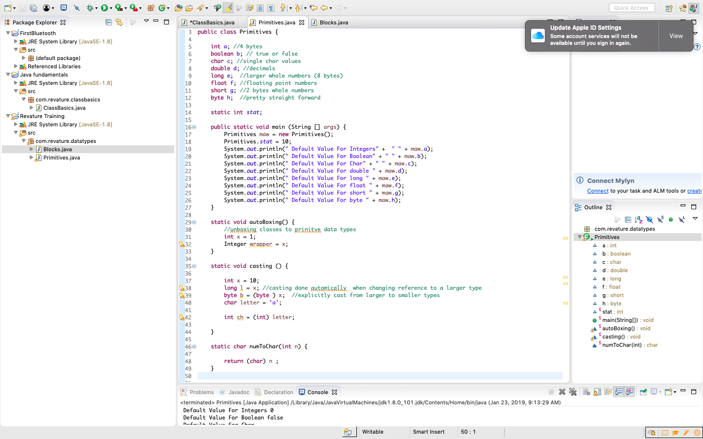

* [operators](https://github.com/1901-jan22-java/1901-jan22-java/blob/master/Week1/docs/operators.md)
* [casting](https://github.com/1901-jan22-java/1901-jan22-java/blob/master/Week1/docs/casting.md) – The process of parsing one primitive data type into another.
* [arrays](https://github.com/1901-jan22-java/1901-jan22-java/blob/master/Week1/docs/arrays.md)
* [control-statements](https://github.com/1901-jan22-java/1901-jan22-java/blob/master/Week1/docs/control-statements.md)
* [classes-and-objects](https://github.com/1901-jan22-java/1901-jan22-java/blob/master/Week1/docs/classes-and-objects.md)
* [stack-vs-heap](https://github.com/1901-jan22-java/1901-jan22-java/blob/master/Week1/docs/stack-vs-heap.md)
* [strings](https://github.com/1901-jan22-java/1901-jan22-java/blob/master/Week1/docs/strings.md)
* [wrapper-classes](https://github.com/1901-jan22-java/1901-jan22-java/blob/master/Week1/docs/wrapper-classes.md)
* [autoboxing](https://github.com/1901-jan22-java/1901-jan22-java/blob/master/Week1/docs/autoboxing.md)
* [package-import](https://github.com/1901-jan22-java/1901-jan22-java/blob/master/Week1/docs/package-import.md)
* [variable-scopes](https://github.com/1901-jan22-java/1901-jan22-java/blob/master/Week1/docs/variable-scopes.md)